Dispersion relation – impactors inside linear chain.

Let us start from Equation (16):
(A1)
We switch to "center of masses-relative displacement" coordinates at each site:
(A2)
In terms of these coordinates, equations (A1) are rewritten as:
(A3)
Let us consider the traveling wave with basic frequency ω and wavevector q. In this case, one can reshape System (A3) in terms of differential-difference equations:
(A4)
The solution of (A4) is searched in terms of Fourier series. The term of nonlinear force is expressed as series of symmetric impacts with frequency ω and amount of momentum transferred in each impact 2p:
(A5)
Substitution of (A5) to (A4) yields the following equations for Fourier coefficients:
(A6)
The solutions for the Fourier coefficients are written as follows:
(A7)
It is convenient to regroup the terms in (A7) and to isolate the nonsmooth (saw-tooth) part of the solution:
(A8)
Here is a saw-tooth function with unit amplitude.
Dispersion relation is obtained from the normalization condition , i.e.
(A9)
In fact, (A9) is exact dispersion relation for the traveling wave that relates the wavenumber q, frequency ω and amount of momentum transferred in each impact at each site, that can be directly related to amplitude or energy density of the wave.
Separation of the saw-tooth part in (A8) and related singular part in (A9) improves the convergence (note that now all terms in the series behave like at infinity). This improved convergence allows one to overcome certain numeric difficulties related to graphical presentation and analysis of the results.
We'll start from exploration of the dispersion relation (A9). For any numeric evaluation, one should leave finite number of terms in expansions (A8-9). Let us truncate the expansions at j=n. For numeric plotting of the dispersion curves, it is easier to remove the singularities by multiplying the truncated expression (A9) by appropriate finite product, as follows:
(A10)
Note: the limit for (A10) has no mathematical meaning!
I used m=1, k=1, μ=0.3, D=1. For different values of p and n one obtains very interesting sets of the dispersion curves. In the figures below, red curve corresponds to bare dispersion relation of the system without the internal impactors , and brown curves – to the branches of dispersion relation (A10). For every value of n, the curves are plotted for .
(a)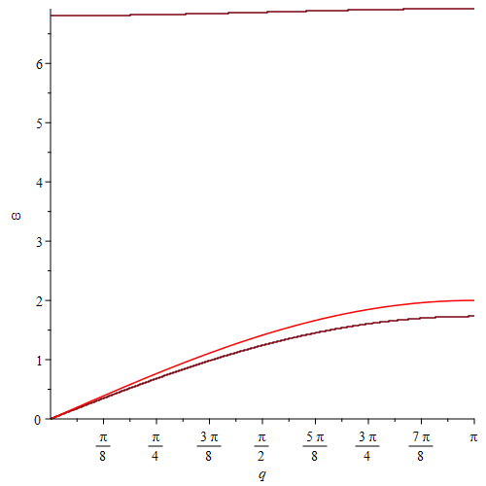(b)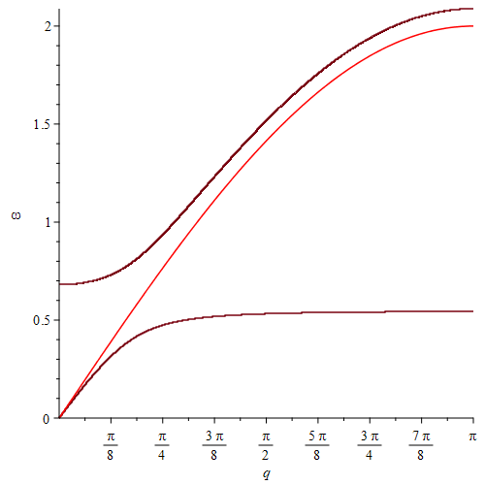

(c)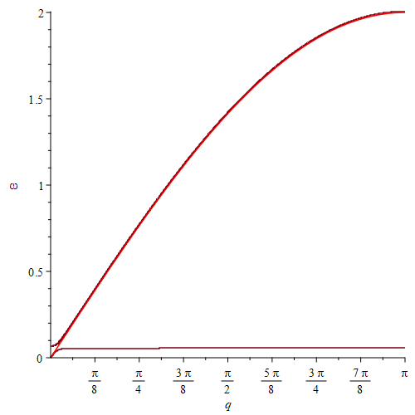
Figure 1. Dispersion relations, n=0,
(a)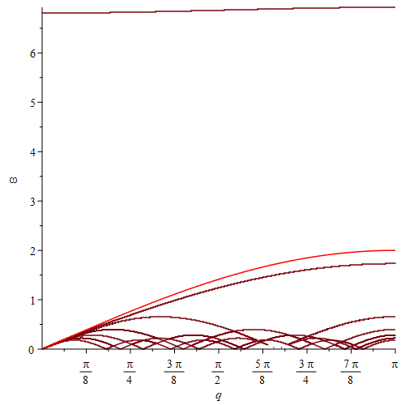(b)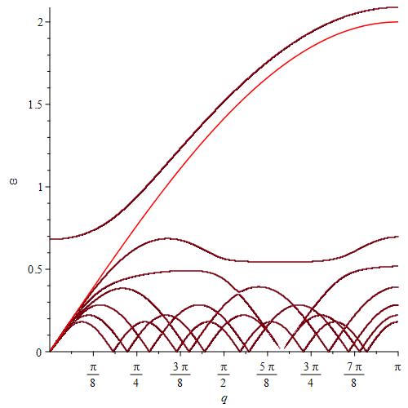

(c)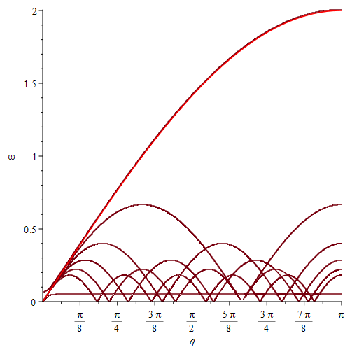

Figure 2. Dispersion relations, n=5,
(a) 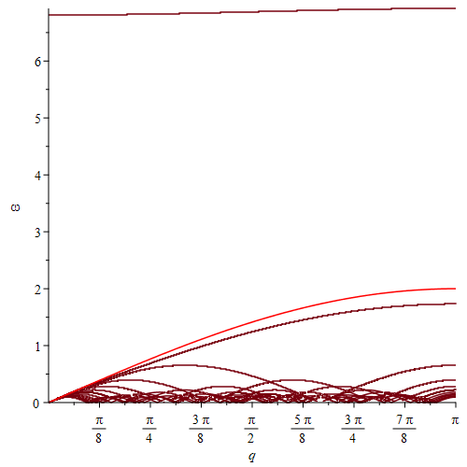(b) 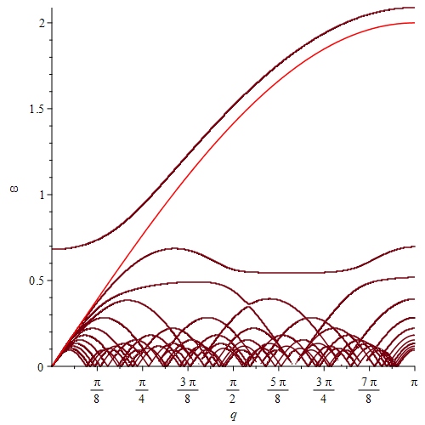
(c) 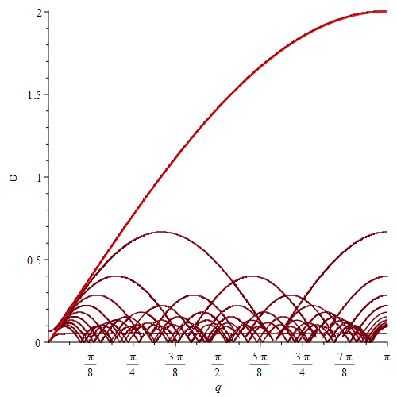

Figure 3. Dispersion relations, n=10,
Some observations concerning the dispersion relations:
- We observe in general three different types of the dispersion curves: single optical branch, single acoustical branch, plethora of subharmonic branches.
- Optical branch tends to horizontal line with high frequency for large p, and approaches the bare acoustical branch for small p.
- Acoustical branch approaches the bare acoustical branch for large p, and zero – for small p
- Subharmonic branches fill a broad passband below the bare acoustical branch.

To understand better the solutions, let us pick . One observes in general 12 branches: 2 basic and n subharmonic. Their frequencies are listed in the following table in the increasing order:
Number | Frequency (numeric) | Basic frequency | Branch characterization
1 | 0.06732208702 |  | SH 1:21
2 | 0.07440300046 |  | SH 1:19
3 | 0.08314738247 |  | SH 1:17
4 | 0.09421877212 |  | SH 1:15
5 | 0.1086869804 |  | SH 1:13
6 | 0.1283940737 |  | SH 1:11
7 | 0.1567995166 |  | SH 1:9
8 | 0.2012230526 |  | SH 1:7
9 | 0.2799524084 |  | SH 1:5
10 | 0.4387564963 |  | SH 1:3
11 | 0.5642767143 |  | Acoustical branch
12 | 1.518130365 |  | Optical branch
The nomenclature of branches is nontrivial – indeed, it is clear that simple frequency relations in the table are valid only for (and maybe also for some other special values of the wavevector). In general, the SH branches are approximately with certain perturbations; the perturbations decrease with growth of j.
To illustrate the time series, we pick some frequencies from the table.
(a) 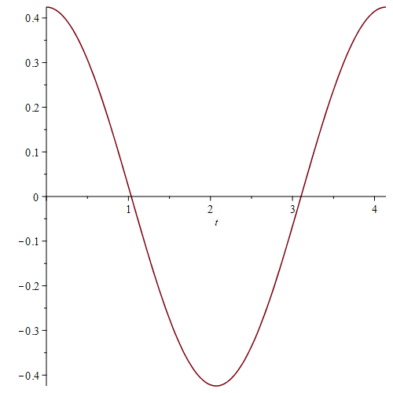 (b) 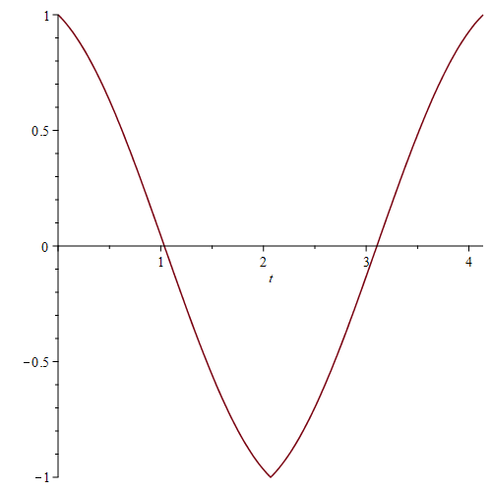
(c) 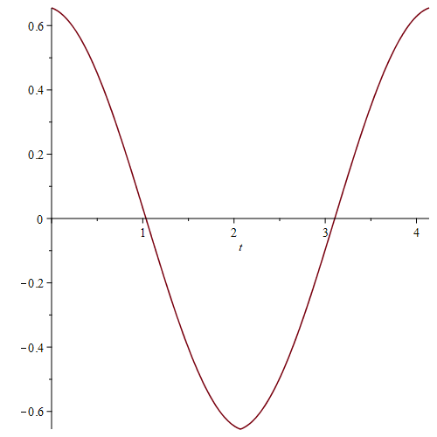(d) 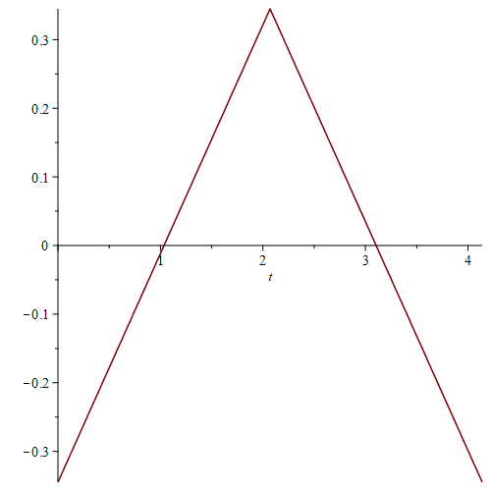
Figure 4. Time series for point 12 (optical branch), (a) R(t), (b) W(t), (c) x(t), (d) y(t).
We observe clear "optical" behavior, where x(t) and y(t) are in anti-phase. Note that y(t) will always be a saw-tooth function (easily derivable from (A8).

(a) 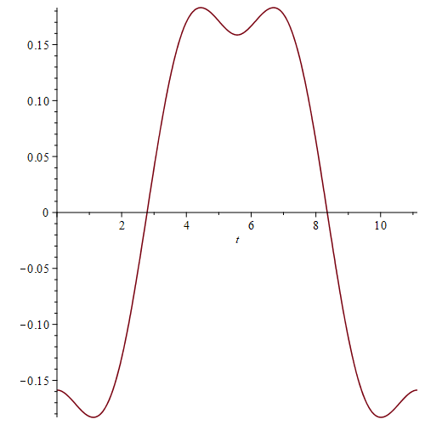 (b) 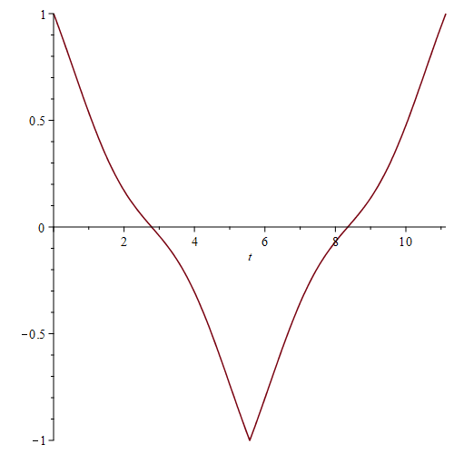
(c) 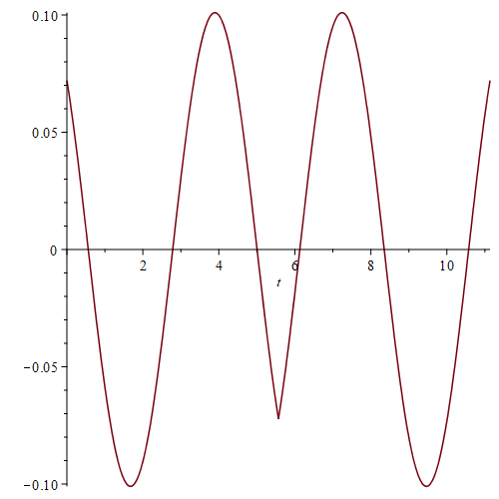 (d) 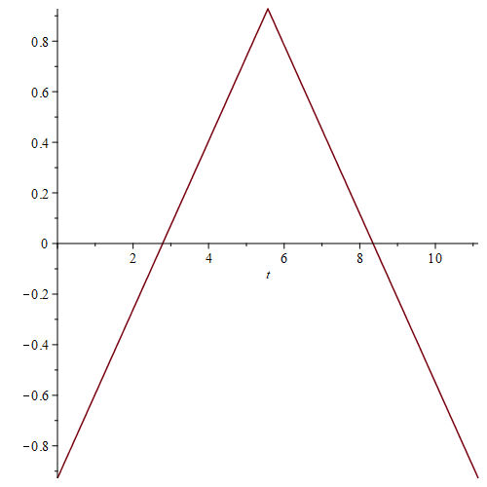
Figure 5. Time series for point 11 (acoustical branch), (a) R(t), (b) W(t), (c) x(t), (d) y(t).
Note that here the response is already clearly multi-frequency – "overtones" are very important here!
(a) 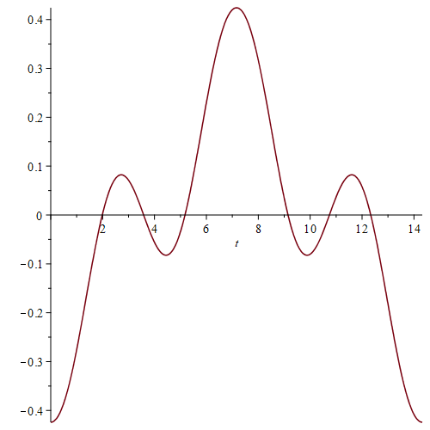 (b) 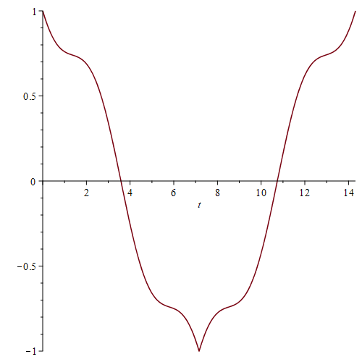
(c) 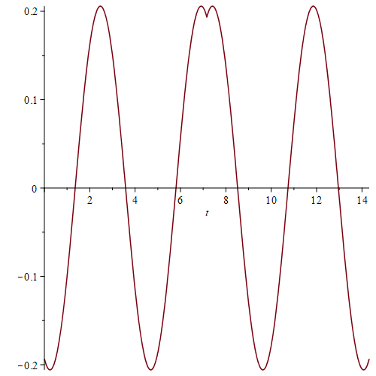 (d) 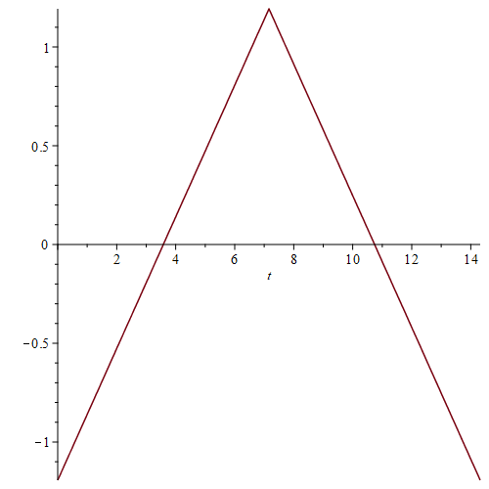
Figure 6. Time series for point 10 (SH 1:3 branch), (a) R(t), (b) W(t), (c) x(t), (d) y(t).
Here 1:3 structure is already clearly observed.
(a) 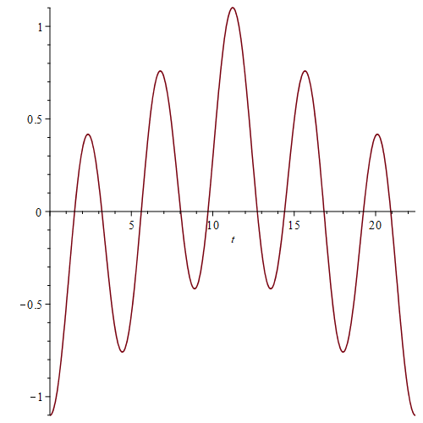 (b) 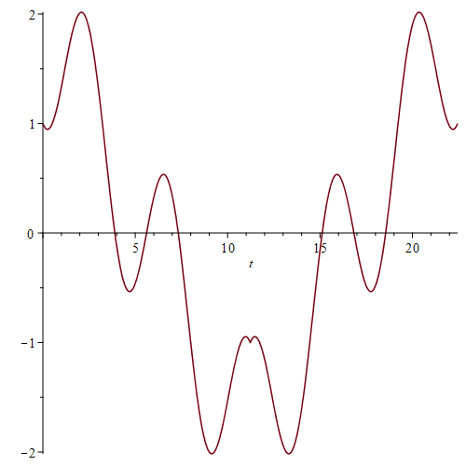
(c) 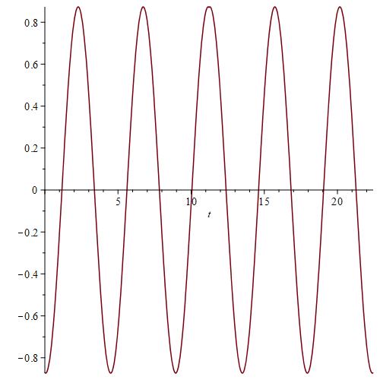 (d) 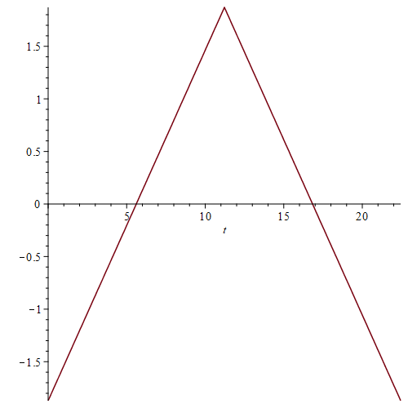
Figure 7. Time series for point 9 (SH 1:5 branch), (a) R(t), (b) W(t), (c) x(t), (d) y(t).
This solution is INCONSISTENT – note that W(t) exceeds unity in some points. However, for lower energies this subharmonic branch readily reveals itself:

(a) 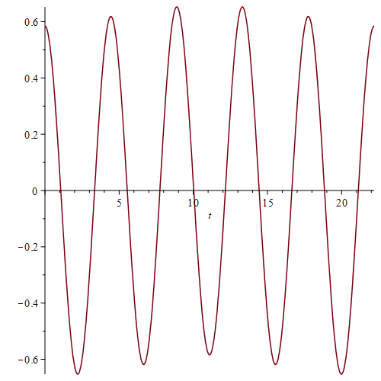 (b) 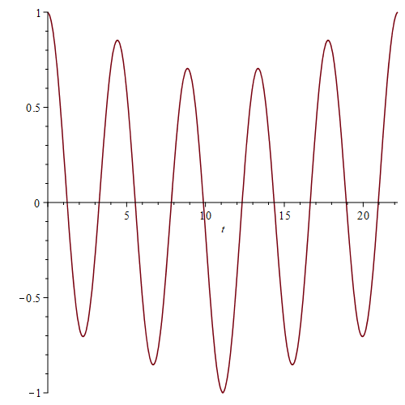
(c) 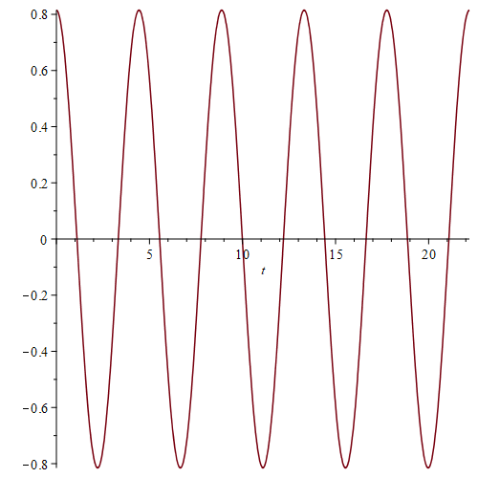 (d) 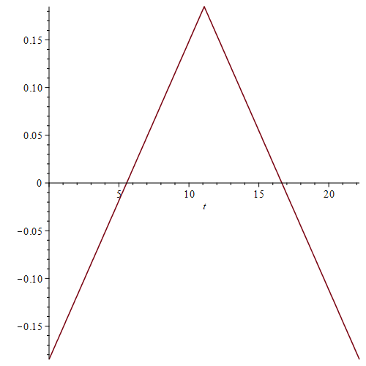
Figure 8. Time series for (SH 1:5 branch), (a) R(t), (b) W(t), (c) x(t), (d) y(t).
The solution is consistent, and 1:5 subharmonic pattern clearly reveals itself.

Some remarks: many of the dispersion curves correspond to the inconsistent solutions and should be removed. It is not very surprising, since form the very beginning we assumed 1:1 symmetric impact. More complicated impact patterns will yield more TW solutions. Besides, nothing is clear about the stability. So, it is really a lot to add and to explore here, but at least we can make some rigorous statements on existence of the traveling waves in this strongly nonlinear and non-integrable system.
What can be explained from these findings?
I think that the spread cloud above the basic branch of the system without impactors in Figure 11 in the paper draft is explained by the fact that the optical branch tends to the basic branch in the limit of low energies. The cloud below the basic branch is related to the acoustical branch (to remind, it "sticks" to the basic branch in the limit of high energies) and to the subharmonic branches.

